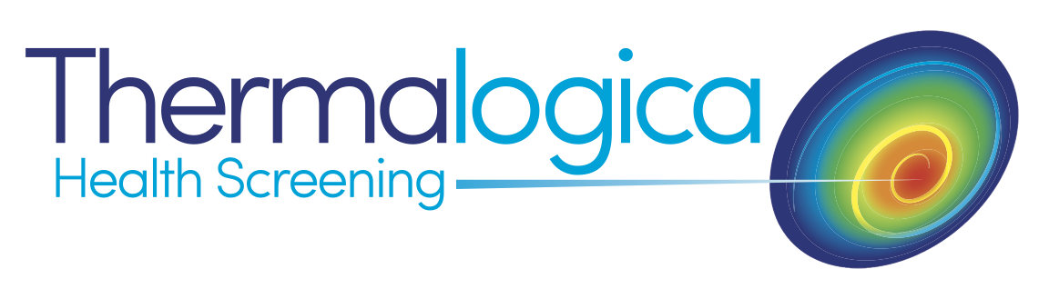

**FULL BODY STUDY QUESTIONNAIRE**

All information given in this questionnaire will remain strictly confidential

and will only be divulged to the reporting Thermologist and any other

practitioner specified by you.

Name: _____________________________________________________

Address: _____________________________________________________

_____________________________________________________

Post Code: ___________________________

Contact No: ___________________________

Email: _____________________________________

D.O.B: ___________________________ (dd/mm/yy)

Your Doctor:_______________________________________________

_______________________________________________

Do you want a copy of the thermogram report forwarded to your doctor or healthcare professional? Y/N

Had a vaccination in last 4 weeks? Indicate which arm: Left: Right: No:

**Please show areas of**:

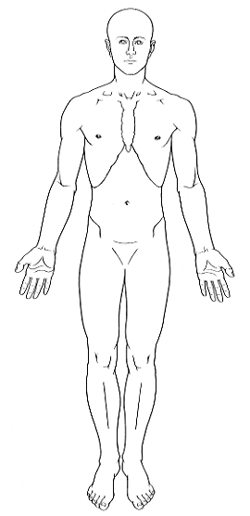 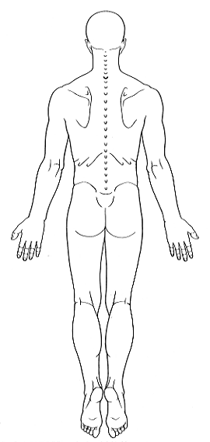 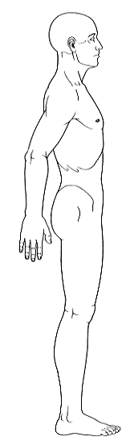 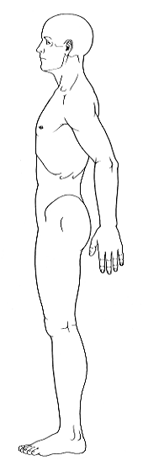

Main Pain **X**

Secondary Pain **O**

Numbness **N**

Pins and Needles **P**

Skin lesions/scarring **//**

Previous operations *

Do you know what triggered the pain?

Does anything relieve it?

Does anything aggravate it?

Has it changed since it began?

Have you had any treatment?

**Patient History – please list below any current health problems, previous injuries, fractures or surgeries:**

**Please list any medications you are currently taking:**

**PATIENT DISCLAIMER: PLEASE READ CAREFULLY**

I understand that the Report generated from my images is intended for the use by trained health care providers to assist in evaluation, diagnosis and treatment. I further understand that the Report is not intended to be used by individuals for self-evaluation or self-diagnosis. I understand that the Report will not tell me whether I have any illness, disease, or other condition but will be an analysis of the Images with respect only to the thermographic findings discussed in the Report.

By signing below, I certify that I have read and understand the statements above and consent to the examination.

**Signature: ____________________________________________________**

**Date: ______________________________________________**